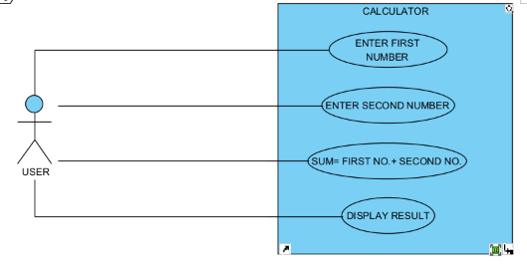
1 A.USE CASE DIAGRAM:

B. PSEUDO CODE:
START
INPUT FIRST NUMBER
INPUT SECOND NUMBER
SUM= FIRST NUMBER + SECOND NUMBER
DISPLAY RESULT
END

2. A.USE CASE DIAGRAM:
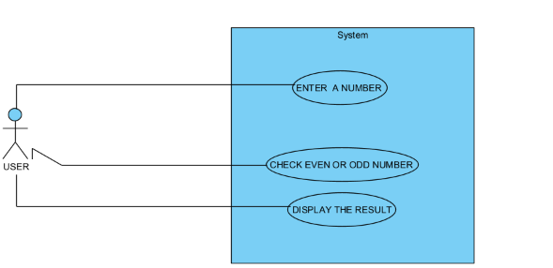

B.PSEUDOCODE:
START
ENTER A NUMBER
CHECK EVEN OR ODD NUMBER
DISPLAY THE RESULT

4. A. USE CASE DIAGRAM
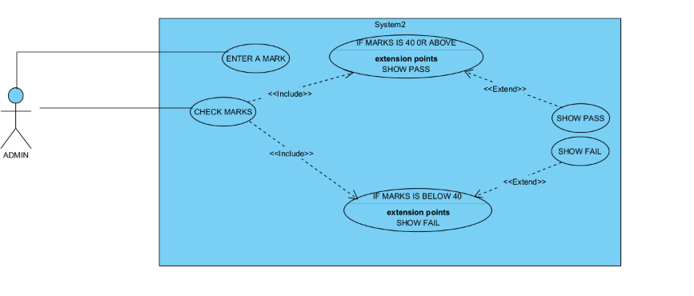
B. PSEUDO CODE
START
ENTER A MARK
CHECK MARKS “IF MARKS IS 40 OR ABOVE”, THEN SHOW PASS AND “IF MARKS IS BELOW 40”, THEN SHOW FAIL.
END

6. A. USE CASE DIAGRAM:
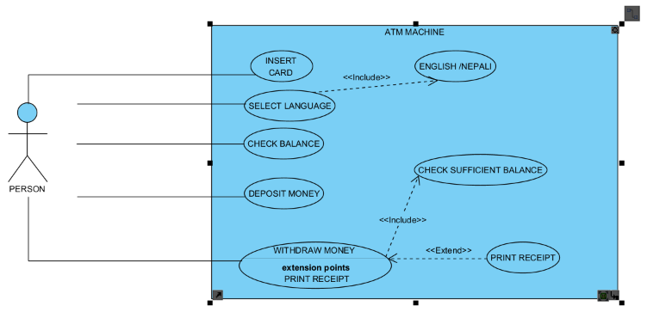
B. PSEUDO CODE:
START
SET BALANCE: RS.10,000
REPEAT
DISPLAY:
- CHECK BALANCE
- DEPOSIT AMOUNT
- WITHDRAW AMOUNT
- EXIT
INPUT CHOICE:
IF CHOICE IS 1 THEN,
DISPLAY BALANCE

IF CHOICE =2
INPUT DEPOSIT AMOUNT
BALANCE= BALANCE+DEPOSIT AMOUNT
SHOW “AMOUNT DEPOSIT SUCESSFULLY”

IF CHOICE = 3 THEN,
INPUT WITHDARW AMOUNT
BALANCE= BALANCE – WITHDRAW AMOUNT
SHOW “AMOUNT WITHDRAW SUCESSFULLY”
ALSO, PRINT RECEIPT

EITHER,
DISPLAY “INSUFFICIENT BALANCE”
THEN END.

IF CHOICE IS 4 THEN,
THANKYOU FOR USING THE ATM.
END

7. USE CASE DIAGRAM:
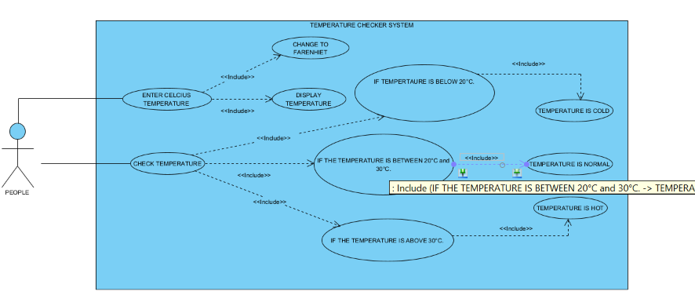

B. PSEUDO CODE:
- START
- ENTER CELCIUS TEMPERATURE
- CHANGE FROM CELCIUS TO FAHRENHEIT
- CHECK TEMPERATURE “IF THE TEMPERATURE IS BELOW 20 DEGREE CELCIUS”, THEN DISPLAY TEMPERATURE IS COLD
- ‘IF THE TEMPERATURE IS BETWEEN 20 AND 30 DEGREE CELCIUS”, THEN DISPLAY TEMPERATURE IS NORMAL
- “ IF THE TEMPERATURE IS ABOVE 30 DEGREE CELCIUS”, THEN DISPLAY TEMPERATURE IS HOT.

